Que1. Write a SQL statement to create a simple table countries including columns country_id, country_name and region_id which already exist.

Que2. Write a SQL statement to create a simple table countries including columns country_id,country_name and region_id.

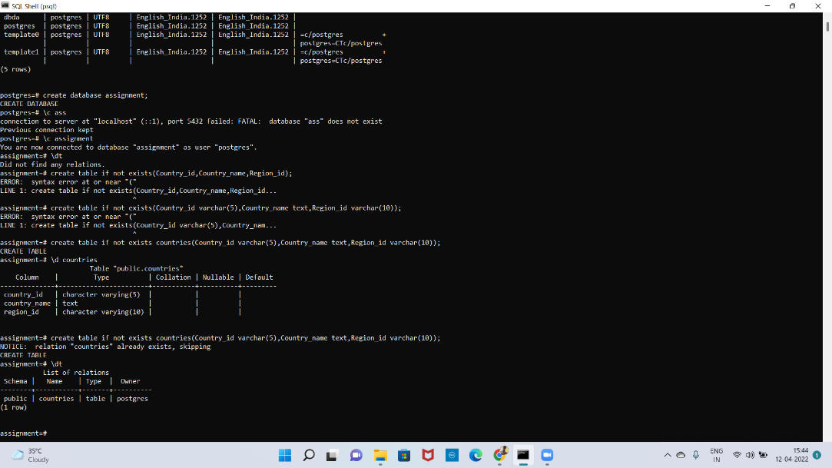

Que3. Write a SQL statement to create the structure of a table dup_countries similar to countries.

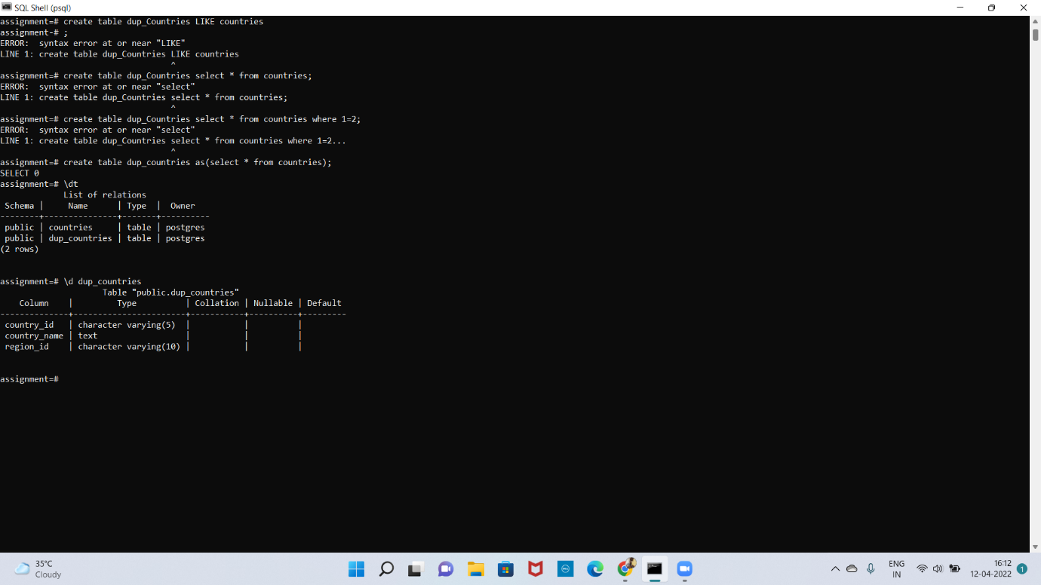

Que4. Write a SQL statement to create a duplicate copy of countries table including structure and data by name dup_countries.

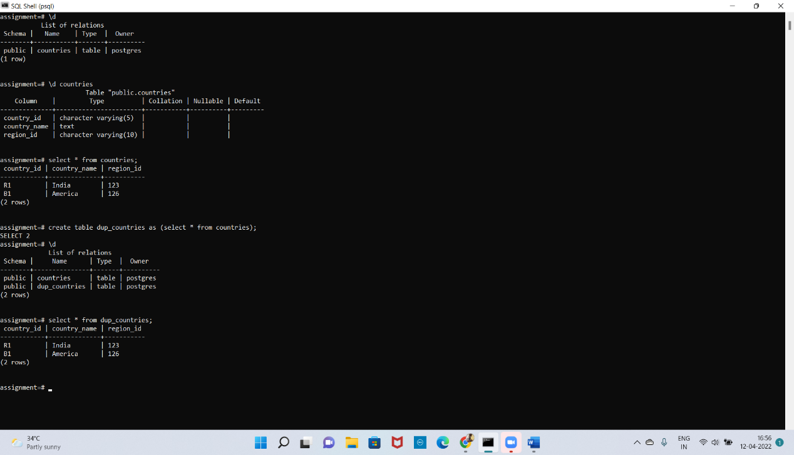

Que5. Write a SQL statement to create a table named countries, including country_id, country_name and region_id and make sure that no duplicate data against column country_id will be allowed at the time of insertion.

